# Assignment 7.

By Jesper Bertelsen, AU-ID: au689481

Indholdsfortegnelse

Assignment 7. 1

Task 1. Optimization of PID Controller Gains Using Genetic Algorithms (GA) 2

a. Interpret and discuss the results obtained from the GA optimization process. 2

b. Present the comparative output results of the model before and after the application of GA optimization. 2

c. Experiment with various GA parameters within the GA_PID_Main.m file, such as the number of generations and population size. Analyze the effects of these modifications on the output performance and simulation duration. 4

d. Define the specific optimization goal targeted by the GA in this assignment. Consider alternative objective functions that could be utilized for GA optimization in this model and explain their potential impact. 5

Task 2. Linearization of a nonlinear system 6

a. Simulate both the original nonlinear system and the linearized LTI system resulting from your linearization efforts. Present the output results for each system in a clearly labeled graphical format. 6

b. Discuss the accuracy of the linearization in capturing the dynamics of the nonlinear system. Consider the range around the operating point where the linear model is a good approximation. 7

c. Explore the effect of choosing different operating points on the accuracy of the linear model. Provide a brief discussion supported by simulations, if necessary. 7

## Task 1. Optimization of PID Controller Gains Using Genetic Algorithms (GA)

Utilize the provided files, … to optimize the performance of the Simulink model…. Subsequently, navigate to GA_PID_Main.m and initiate the run sequence.

### Interpret and discuss the results obtained from the GA optimization process.

After 29 generations it seems like the best fit is locked at 6295.

After 74 generations it seems like the mean fit is locked at 6295.

The best fit didn’t start too far away from the ideal fit with it starting at 6377.

The mean fit started further away from the ideal fit with its starting value at 6884.

After 90 generations the average change was less than the threshold. The most optimized values had been found:

### Present the comparative output results of the model before and after the application of GA optimization.

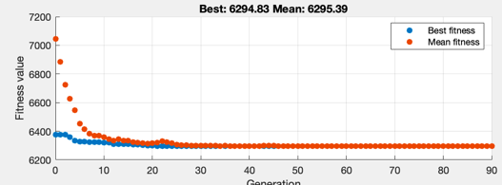

The optimization simulation:

Before the optimization:

The PID values aren’t hard coded, they are chosen. I figured out, that if you were to stop the simulation early, then you would get the found values, but not until stopped.

I then stopped the optimization at 2nd generation.

Comparison:

Before After

The PID values



Velocity: Reasonable errors.

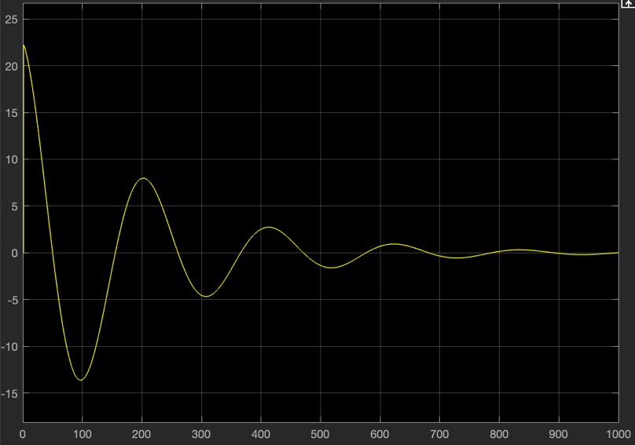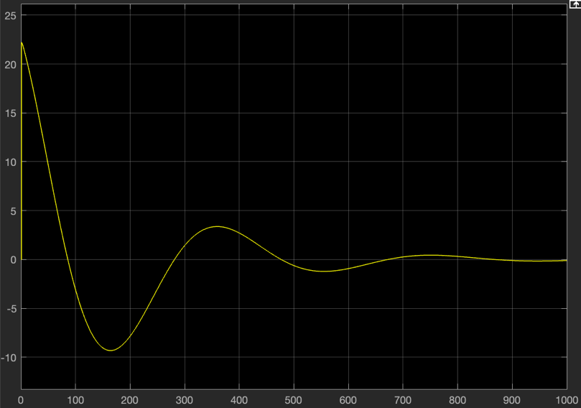



The errors in the system. Reasonable size of the errors.

The quick rise time of the optimized system has the con of slower settling time.

The PID specifications.

### Experiment with various GA parameters within the GA_PID_Main.m file, such as the number of generations and population size. Analyze the effects of these modifications on the output performance and simulation duration.

My prediction is, that with an increase in population size, I might get a different combination as the population is broader, but I think that the optimal fit will be found faster than the previous 90 generations.

Testing with a population size

$p_{1}=10·p_{0}=500$

I let the simulation run for a while, and then stopped it myself, as it was about 10 times as slow, which makes sense, as it is calling the function about 10 times more than at first.

A 10 times population increase didn’t decrease the settling of the fitness by 10 though.

At 15 generations the best fit settled at 6295. At 24 generations, which is the newest generation I reached, the average fit was close to settling at 6295, with the last 5 generations closing in on 6295.

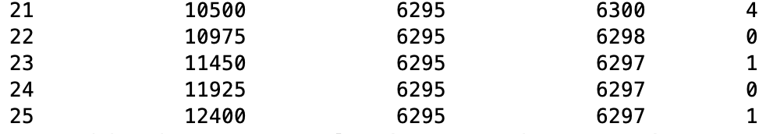

Say the average fit settled at 6295 on the 30th generation, that would make this setup require:

About half the generations to settled with the best fit.

About 40% of the generations used to find the average fit.

With a time spend at about 10 times the usual genetic optimization and with me calculating efficiency as:

$$t_{f}·g_{f}=effiecieny$$

The best fit would be 5 times slower

The average fit would be 4 times slower

With this setup.

### Define the specific optimization goal targeted by the GA in this assignment. Consider alternative objective functions that could be utilized for GA optimization in this model and explain their potential impact.

Looking at the code I noticed the performance metric in the Gain function.



The error is said to be

$$error={\left(v_{inp}-v_{out}\right)}^{2}$$

The cost variable must then be what determines a good chosen child.

Which child has the smallest error, at the earliest of time.

In otherwords, the genetic algorithm looks for the best rise time.

The rise time makes sense when we are only simulating for the first 10 seconds. If we were to change the simulation time to say a thousand, two criterias that might be interesting to look at too could be settling time or overshoot.

## Task 2. Linearization of a nonlinear system

This assignment involves the linearization of the nonlinear system depicted in the provided

Simulink file, ‘Linearization.slx’. Follow the detailed steps outlined in the accompanying

PDF document 'Linearization' to linearize the system around the operating point of 4.5.

### Simulate both the original nonlinear system and the linearized LTI system resulting from your linearization efforts. Present the output results for each system in a clearly labeled graphical format.

The original simulation:

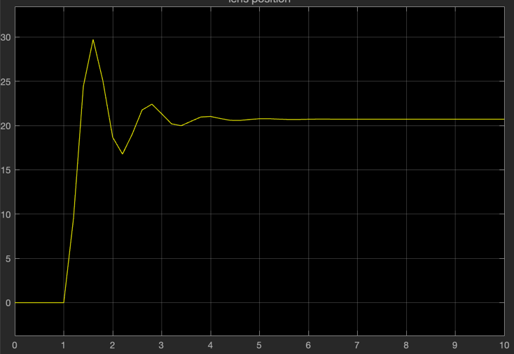



This model can be split into 4 sections.

$f\left(t\right)=\left\{\begin{aligned}0, t <1 \\ \frac{30-0}{1,6-1}t, 1<t<1,6 \\ \frac{20-30}{1,955-1,6}t, 1,6<t<1,955 \\ 20,5, 1,955<t\end{aligned}\right\}$

Placing the operating point at 1 I linearized the system:

The setup:

The results:

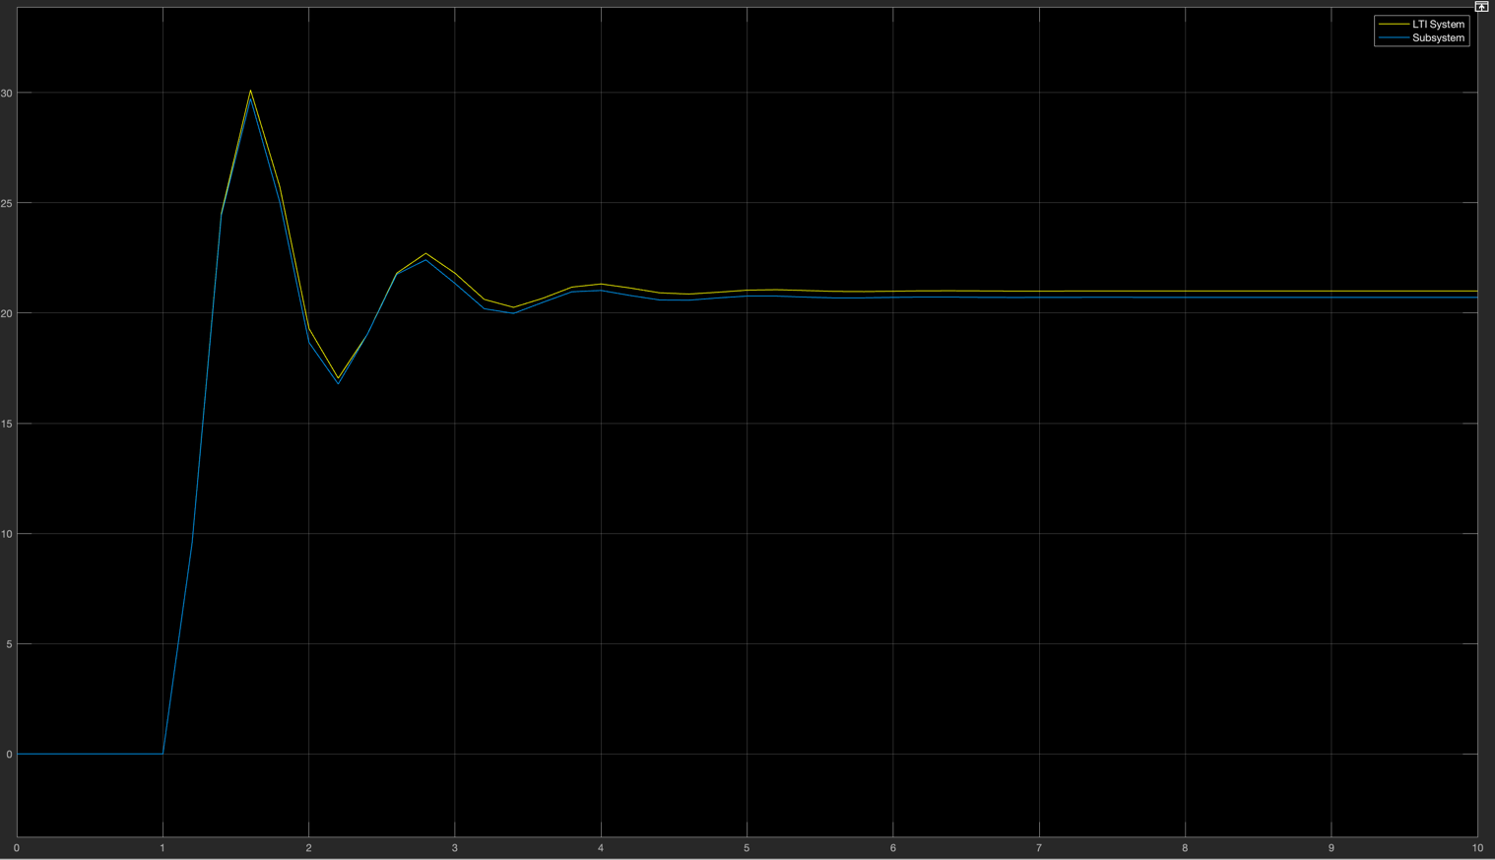

### Discuss the accuracy of the linearization in capturing the dynamics of the nonlinear system. Consider the range around the operating point where the linear model is a good approximation.

I fell like the linearization did a good job, without too many errors, the biggest probably being in the range 3 +- 0.1.

My linearization would have been much more general than this model, with only 4 sections. This model made sections from every change in slope.

### Explore the effect of choosing different operating points on the accuracy of the linear model. Provide a brief discussion supported by simulations, if necessary.

I chose 4 different operating points

The original system compared to the linearized systems at $t_{0} \& t_{1}$. Both linearization’s to these times have the same coefficients.

The original system against the once at $t_{2}\&t_{3}$ both linearization models overlapping as with the previous one.